
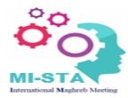

IEEE 6th International Maghreb Meeting of the Conference on Sciences and Techniques of Automatic control and Computer Engineering


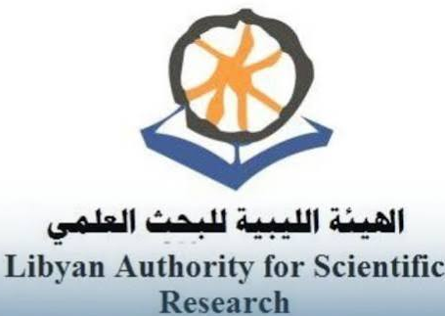


April 25 – 27, 2027, ALBAYDA- LIBYA

Special Session Chairs:
- Nasar-Aldian SHASHOA (Libya)
- Assem THABET (Tunisia)

Proposals should be submitted in PDF format via email to the Special Session Chair: nasar-shashoa@ieee.org

